International School

Project Proposal Document
Course: System Integration Practices
Project Title: Company X – Integrated HR & Payroll Management Dashboard
Case Study 1: Problem Statements
Version: 1.0
Date: 18/01/2026
Group: 5
Semester: Semester II – Year III
Instructor: MSc Huy, Nguyen Dang Quang

Team Members:
Name | Student ID
Nguyen Van Duy Manh | 29211100024
Tran Van Loi | 29211352994
Tran Viet Loc | 29211358847
Huynh Tran Tin | 29211159367
Dang Dai Viet | 29211155820

Approved by
MSc Huy, Nguyen Dang Quang

Da Nang 01/2026
Project Acronym | HRD
Project Title | Company X – Integrated HR & Payroll Management Dashboard
Start Date | 18 January 2026 | Start Date | 15 May 2026
Lead Institution | International School, Duy Tan University
Role | Name | Role |  | Name
Project Mentor | Nguyen Dang Quang Huy | huyndq@duytan.edu.vn |  | 0935525354
Team Members | Nguyen Van Duy Manh | duymanhdnvn1@gmail.com |  | 0779534325
 | Tran Viet Loc | tranvietloc288@gmail.com |  | 0365957050
 | Huynh Tran Tin | trantin202ad@gmail.com |  | 0899565751
 | Tran Van Loi | tvl19012005@gmail.com |  | 0898238541
 | Dang Dai Viet | vdang9721@gmail.com |  | 0384165721

DOCUMENT INFORMATION
Document Title | Software Project Proposal Document
Reporting Period | 18 – January – 2026
Author(s) | Nguyen Van Duy Manh
Role | Developer
Date | 18/01/2026 | File name | 1. Proposal Document_IEEE 830-1998.docx

DOCUMENT APPROVALS
Document Approvals: The following signatures are required for approval of this document.
Mentor | Huy, Nguyen Dang Quang | Signature:
 |  | Date:
Team member(s) | Nguyen Van Duy Manh | Signature:
 |  | Date:
 | Tran Viet Loc | Signature:
 |  | Date:
 | Huynh Tran Tin | Signature:
 |  | Date:
 | Tran Van Loi | Signature:
 |  | Date:
 | Dang Dai Viet | Signature:
 |  | Date:

TABLE OF CONTENTS
1. Introduction 1
1.1. Purpose of the Document 1
1.2. Scope of the Document 1
1.3. Definitions, Acronyms, Abbreviations 2
1.4. References 2
1.5. Overview 3
2. Project Overview 3
2.1. Background 3
2.2. Business Motivation 3
3. Business Problem Analysis 4
4. Proposed Solution 5
5. System Context Diagram: 5
6. Project Objectives 6
6.1 General Objective 6
6.2 Specific Objectives 6
7. Project Scope, Assumptions, and Constraints 6
8. System Architecture and Technology Stack 7
9. Project Planning and Milestones 7
10. Estimated Resources and Cost (for Educational Purposes) 8
11. Expected Outcomes 8

1. Introduction

1.1. Purpose of the Document
- This Project Proposal serves as the architectural blueprint for the Integrated HR & Payroll Middleware Dashboard (Company X). It defines the strategic scope, integration workflows, and SDLC phases required to resolve existing systemic silos, ensuring strict compliance with the System Integration Practices course standards.
- The intended audience includes:
- Instructor / Evaluator: For assessment of architectural decisions, course CLOs, and ABET alignment.
- Development Team: As the definitive technical reference for API integration, database mappings, and sprint execution.
- Enterprise Stakeholders (CEO, HR, Finance): To ensure business requirements, security mandates, and non-invasive constraints are strictly met.

1.2. Scope of the Document
- This document covers (In-Scope):
- Strategic Alignment: Identification of enterprise business challenges and operational bottlenecks as outlined in the CEO Memo.
- Integration Boundaries: Definition of synchronization workflows and data mapping objectives between the legacy HR (HUMAN_2025) and Payroll (payroll_2026) databases.
- Proposed Architecture: A high-level blueprint of the technology stack, middleware solution, and expected system deliverables.
- Project Roadmap: A comprehensive preliminary SDLC plan, including sprint timelines, key milestones, and resource allocation.
- This document explicitly does not include (Out-of-Scope):
- Low-Level Engineering: Granular system design, internal module logic, or code-level specifications.
- Invasive Modifications & Hardware: Any alterations to the existing legacy database schemas (strictly non-invasive approach) or Physical Infrastructure Setup (servers/hardware).
- Implementation: Actual coding of backend RESTful APIs and UI components (deferred to subsequent Case Studies 3, 4, and 5).

1.3. Definitions, Acronyms, Abbreviations
Acronym | Definition
ABET | Accreditation Board for Engineering and Technology
CLO | Course Learning Outcome
CRUD | Create, Read, Update, Delete
DAL | Data Access Layer
IEEE | Institute of Electrical and Electronics Engineers
RBAC | Role-Based Access Control
REST | Representational State Transfer
SPA | Single Page Application
API | Application Programming Interface
SDLC | Software Development Life Cycle

1.4. References
- IEEE Computer Society, IEEE Standard for Software Project Management Plans (IEEE Std 1058-1998).
- IEEE Computer Society, IEEE Recommended Practice for Software Requirements Specifications (IEEE Std 830-1998).
- Anthony J. Lattanze, Architecting Software Intensive Systems: A Practitioner’s Guide, 2008.
- CEO MEMO – Company X (Internal Simulation Document), 2025.
- System Integration Practices Course Syllabus, CMU-CS 445 DIS, 2025 –2026 Edition.

1.5. Overview
- Section 2 describes the project background, business motivation, and operational context.
- Section 3 analyzes the current business problems, emphasizing inefficiencies in the siloed HR and Payroll systems.
- Section 4 presents the proposed Middleware Dashboard Solution, outlining key features and integration strategies.
- Section 5 defines the specific project objectives to be achieved.
- Section 6 details the project scope, assumptions, and constraints.
- Section 7 specifies the System Architecture and Technology Stack, including the backend API, frontend dashboard, and security modules.
- Section 8 outlines the 12-week Project Implementation Plan, aligned with the required Case Studies.
- Section 9 provides an estimation of resources and simulated costs.
- Section 10 summarizes the expected learning outcomes and success criteria.
- Section 11 contains the formal approval and sign-off records.

2. Project Overview

2.1. Background
- Company X’s current IT infrastructure relies on two disparate, siloed legacy systems:
- HUMAN_2025 (SQL Server): Acts as the primary Human Resources information system, managing core employee demographics, departmental structures, job positions, and internal shareholder dividends.
- payroll_2026 (MySQL): Functions as the financial engine handling employee compensation, bonuses, deductions, and attendance tracking.
- The lack of integration between these systems causes severe data duplication and forces HR and Finance to perform manual data reconciliation. This operational bottleneck increases the risk of human error, reporting delays, and compliance violations.

2.2. Business Motivation
- The CEO has mandated the development of an integrated system that:
- Reduces manual synchronization between HR and Payroll.
- Improves real-time access to consolidated employee and payroll information.
- Provides analytical dashboards for management decision-making.
- Enables proactive management through automated alerts for critical HR and Payroll events.
- This integration will enhance data consistency, operational efficiency, and decision accuracy across departments.

3. Business Problem Analysis
Problem | Description | Consequence
Data Fragmentation | HR and Payroll maintain disconnected employee records | Inconsistent data and conflicting "sources of truth".
Reporting Latency | Payroll reporting relies heavily on manual HR updates. | Delayed executive decision-making.
Lack of Integration | Systems do not communicate or share updates automatically | Reduced efficiency
Compliance Risk | Manual data entry may lead to calculation errors | Risk of regulatory non-compliance
Lack of Automated Alerts | No proactive notifications for work anniversaries, leave limits, or salary anomalies. | Managers miss critical events; delayed reaction to HR violations.

4. Proposed Solution
- We propose a centralized Middleware Dashboard System to bridge the siloed databases without modifying their legacy schemas (strictly non-invasive).
- Key Architectural Features:
- Unified Data Access Layer (DAL): Centralized APIs connecting HUMAN_2025 and payroll_2026 for real-time data synchronization.
- Independent Security Module: A standalone Auth_DB managing RBAC and Audit Logs, preserving legacy schemas.
- Automated Synchronization: Background cron-jobs ensuring continuous HR-to-Payroll data consistency.
- Business Intelligence Dashboard: A React-based frontend delivering unified analytics across demographics, dividends, and payroll.
- Smart Alert System: Automated engine for anomaly detection (e.g., salary discrepancies) and notifications.

5. System Context Diagram:
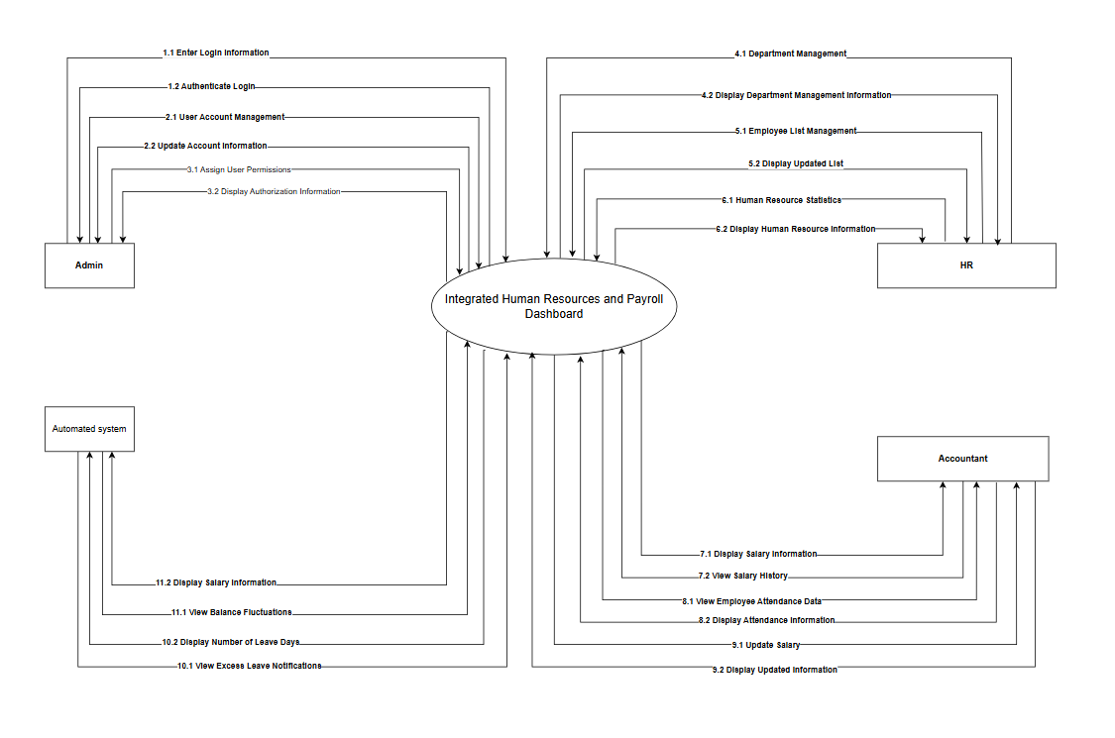

6. Project Objectives

6.1 General Objective
- To design and implement an integrated dashboard that unifies HR and Payroll data, improving accuracy, efficiency, and management insights.

6.2 Specific Objectives
- Analyze existing system workflows and identify integration points between HUMAN_2025 and payroll_2026.
- Define detailed data mapping schemas to ensure accurate synchronization of employee and salary records.
- Design and implement a secure Authentication Module using a dedicated Auth_DB (PostgreSQL) for Role-Based Access Control (RBAC).
- Develop prototype UI screens for employee management, payroll processing, and attendance tracking.
- Plan and document RESTful integration APIs for CRUD operations and data synchronization.
- Implement automated alert mechanisms and reporting components for strategic decision-making.

7. Project Scope, Assumptions, and Constraints
Category | Description
In-Scope | Integration of HR and Payroll data, dashboard design, and report planning.
Out-of-Scope | Database schema redesign, Physical Infrastructure Setup (Hardware/Servers), and third-party integrations.
Assumptions | Both databases contain accurate and valid data; team members have basic knowledge of SQL, API, and web frameworks.
Constraints | Limited time (12 weeks); educational simulation environment only.

8. System Architecture and Technology Stack
Layer | Technology | Description
Backend | Python FastAPI | High-performance asynchronous API framework for bridging systems.
Database | SQL Server (HUMAN_2025), MySQL (payroll_2026), SQLite (Auth) | Legacy data sources + Local SQLite auth.db for security.
Frontend | ReactJS (TypeScript) + Vite | Fast, interactive SPA Dashboard with strict type-safety.
Authentication | Custom Token-based Auth | Stateless session management securely stored in SQLite.
Export/Reporting | jsPDF & SheetJS (XLSX) | Client-side generation of Executive PDF and Excel reports.
Testing | Selenium | API and data validation
Background Jobs | APScheduler | Automated cron-jobs for real-time reconciliation checks.

9. Project Planning and Milestones
Week | Case Study | Deliverables | Key Activities
1–2 | Case Study 1 | Project Proposal, Project Plan, BRD | Problem Identification & Proposal
3–4 | Case Study 2 | SRS, UI/UX Design, Data Mapping | Design system model and integration logic
5-6 | Case Study 3 | API Implementation | Develop backend APIs for CRUD operations
7-8 | Case Study 4 | Security Integration | Implement authentication & authorization
9-11 | Case Study 5 | Final Dashboard | Integrate APIs, reports, and alerts
12 | Final | Testing | User Acceptance Testing, Deployment Simulation, Project Closure

10. Estimated Resources and Cost
Resource | Description | Cost
Development Tools | VS Code, Visual Studio, MySQL Workbench | Free
Cloud/Local Deployment | Simulated via Docker | Free
Project Time | 12 weeks (student workload) | 100$
Documentation Tools | Google Docs, GitHub | Free

11. Expected Outcomes
- Apply system integration models to real-world business scenarios.
- Design and develop RESTful APIs connecting heterogeneous databases.
- Implement access control and authentication mechanisms.
- Create and visualize data via web-based dashboards.
- Prepare professional documentation consistent with IEEE and ABET standards.

